# MODERN APPLICATION DEVELOPMENT JAVA SPRING BOOT

**WEEK-2 ASSIGNMENT**

# Reg.No:20MIS0440 Name : AZHAGIRI S

**Email:** [**azhagiri.s2020a@vitstudent.ac.in**](mailto:azhagiri.s2020a@vitstudent.ac.in)

**Drive link:**

1. **Create, Update, Delete commands in MySQL Create table :**

# Code:

CREATE TABLE Persons ( PersonID int,

LastName varchar(255), FirstName varchar(255), Address varchar(255), City varchar(255)

);

# Output:

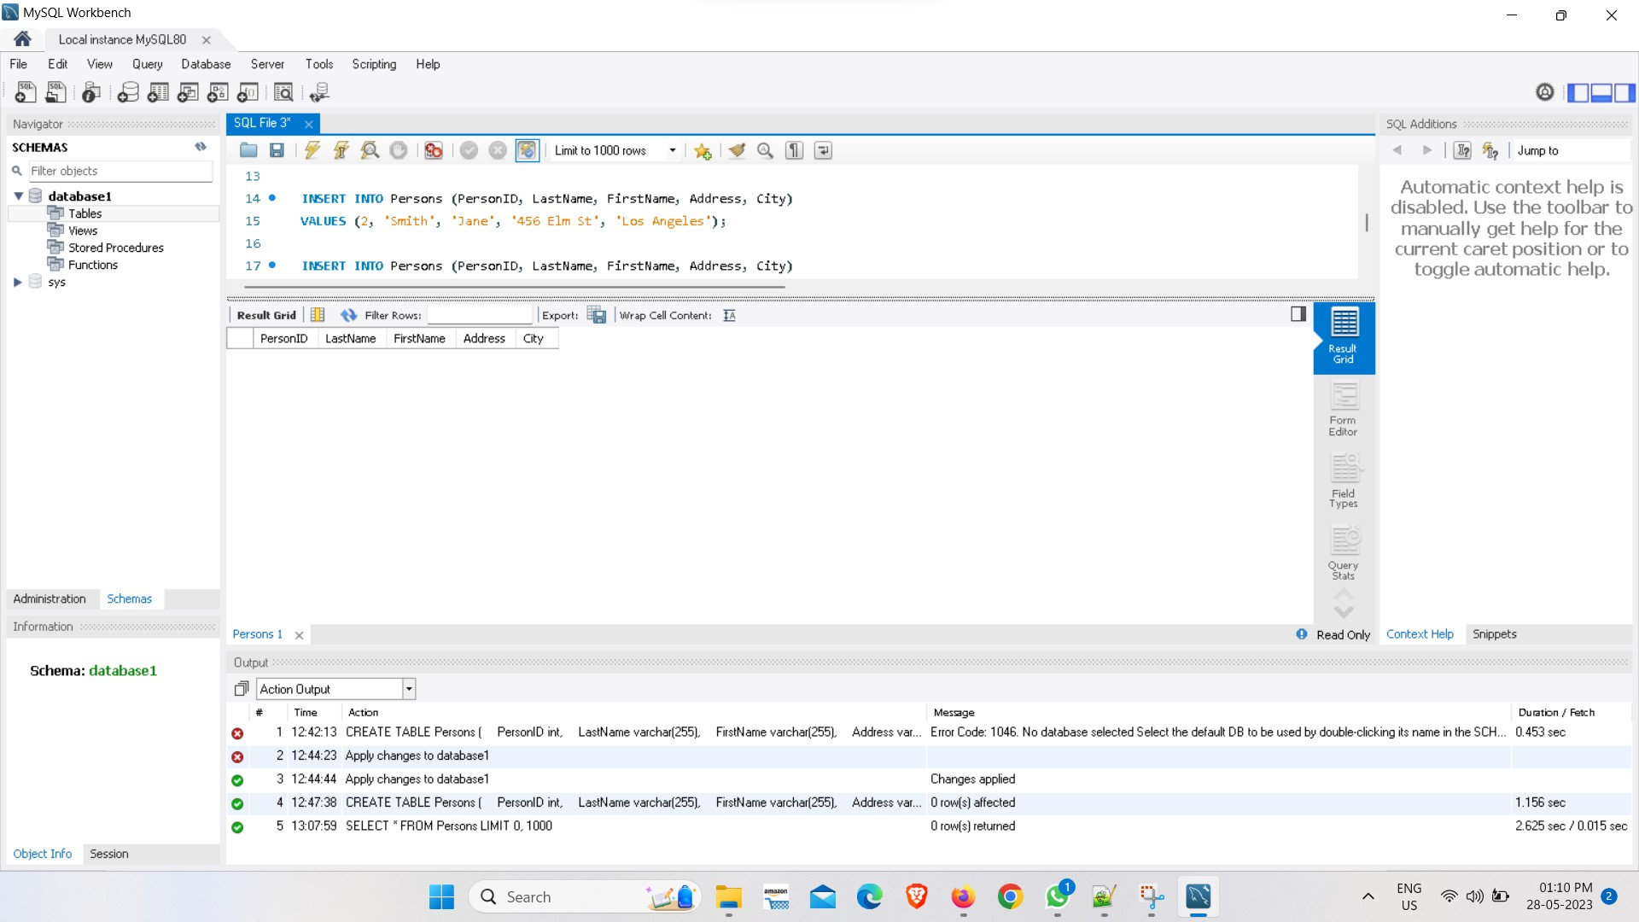

**Insert:**

# Code:

INSERT INTO Persons (PersonID, LastName, FirstName, Address, City) VALUES (1, 'Doe', 'John', '123 Main St', 'New York');

INSERT INTO Persons (PersonID, LastName, FirstName, Address, City) VALUES (2, 'Smith', 'Jane', '456 Elm St', 'Los Angeles');

INSERT INTO Persons (PersonID, LastName, FirstName, Address, City) VALUES (3, 'Johnson', 'Michael', '789 Oak St', 'Chicago');

INSERT INTO Persons (PersonID, LastName, FirstName, Address, City) VALUES (4, 'Williams', 'Emily', '987 Pine St', 'San Francisco');

INSERT INTO Persons (PersonID, LastName, FirstName, Address, City) VALUES (5, 'Brown', 'Olivia', '654 Cedar St', 'Seattle');

# Output:

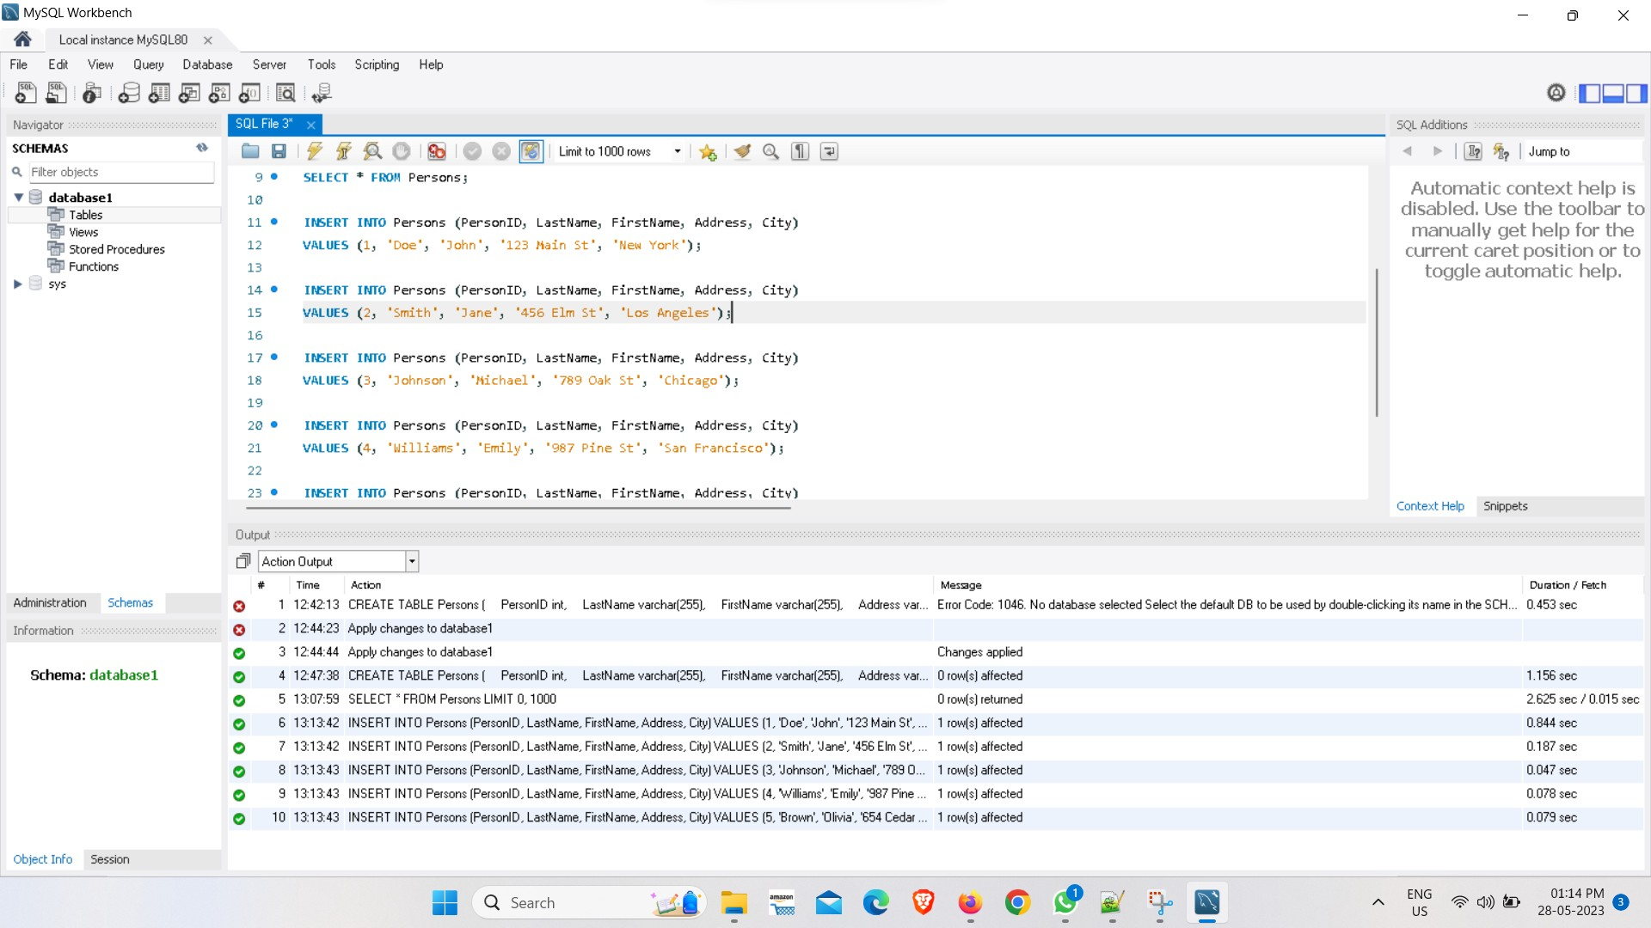

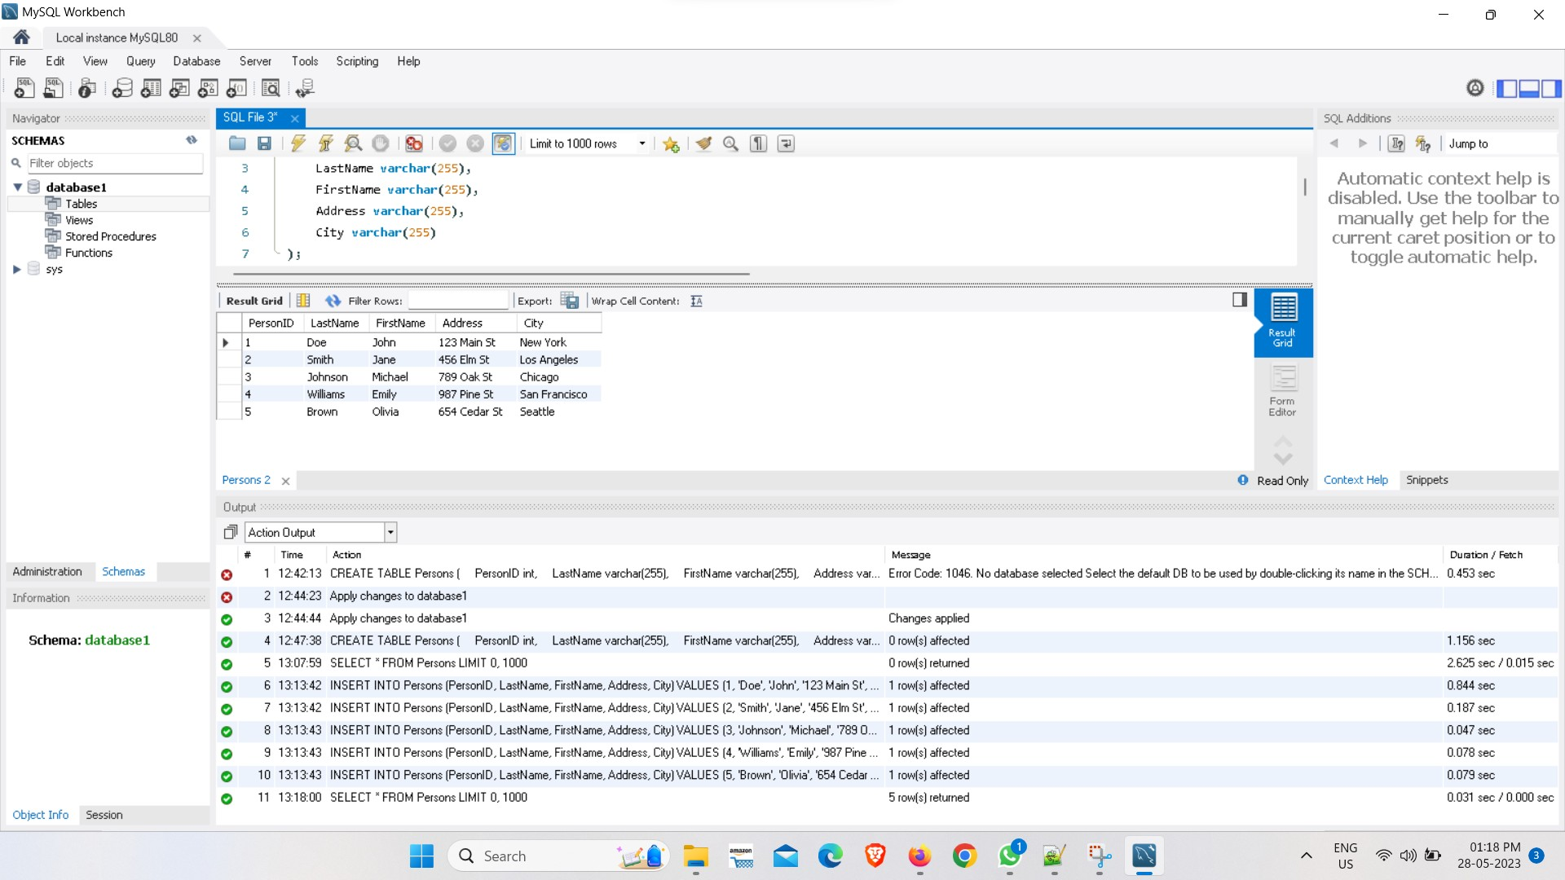

**Update: Code:**

UPDATE Persons

SET Address = '343 Will st' WHERE PersonID = 4;

# Output:

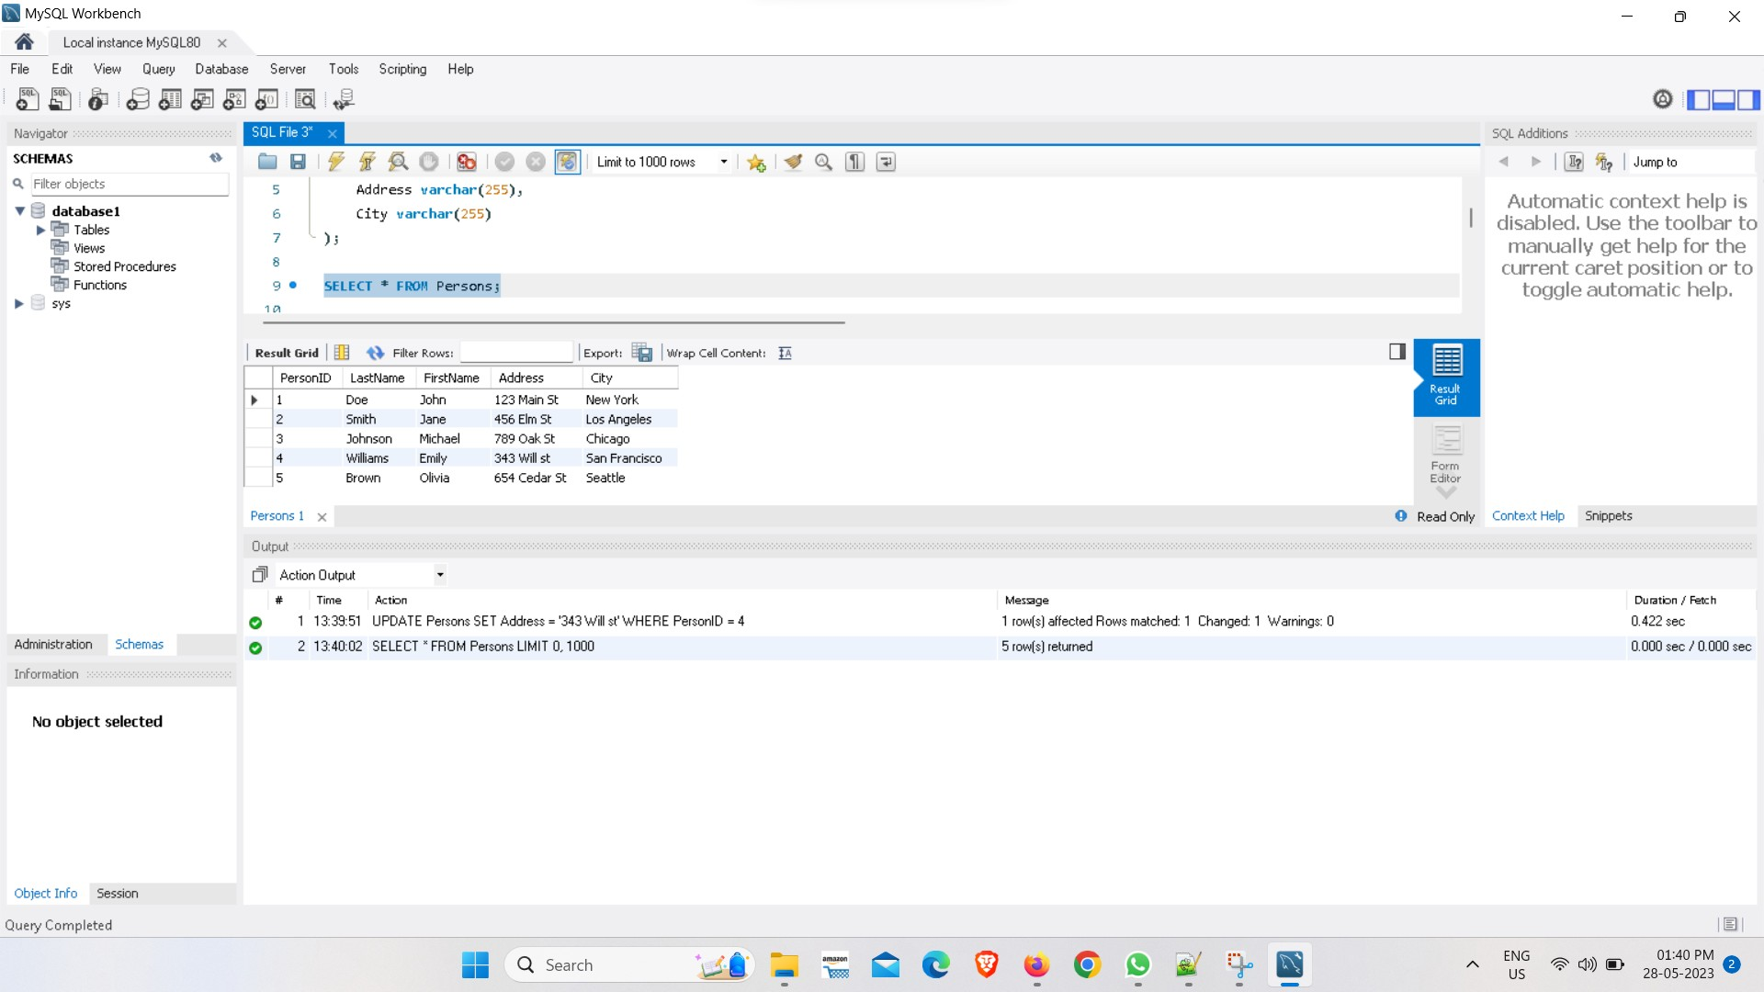

**Delete:**

DELETE FROM Persons WHERE PersonID = 3;

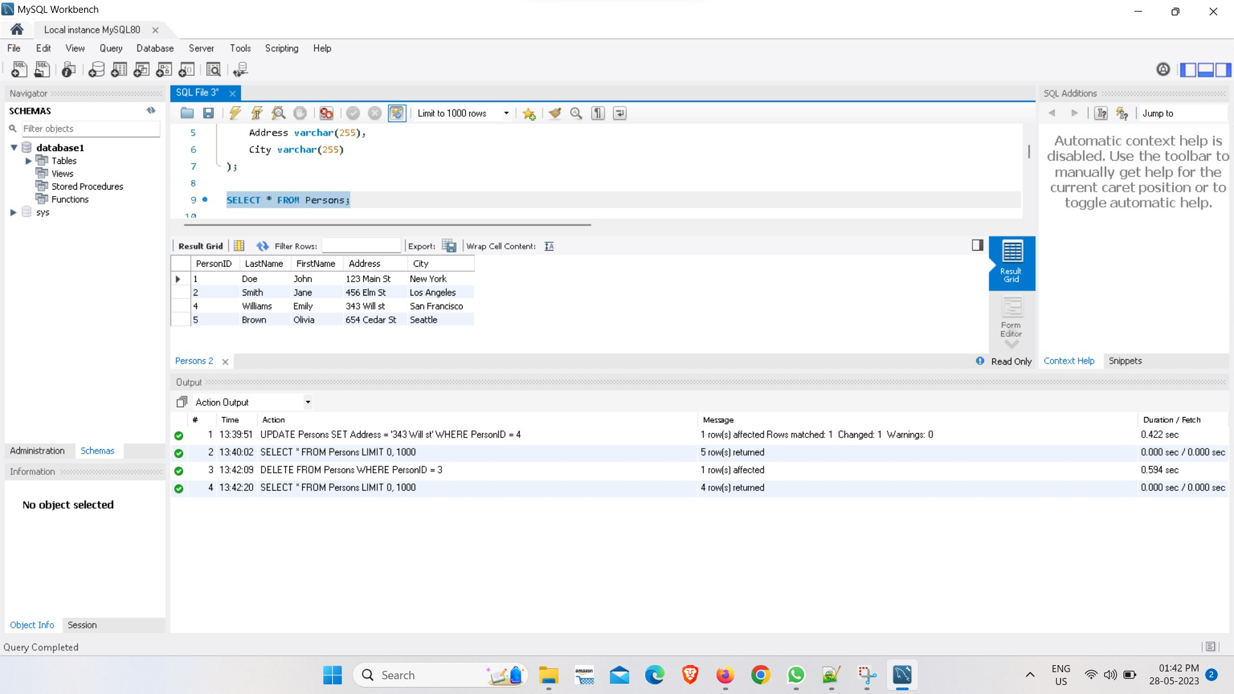

# Create table and joins in MySQL Code:

**Create table:**

CREATE TABLE Customers ( CustomerID int, FirstName varchar(255), LastName varchar(255), Email varchar(255),

PRIMARY KEY (CustomerID)

);

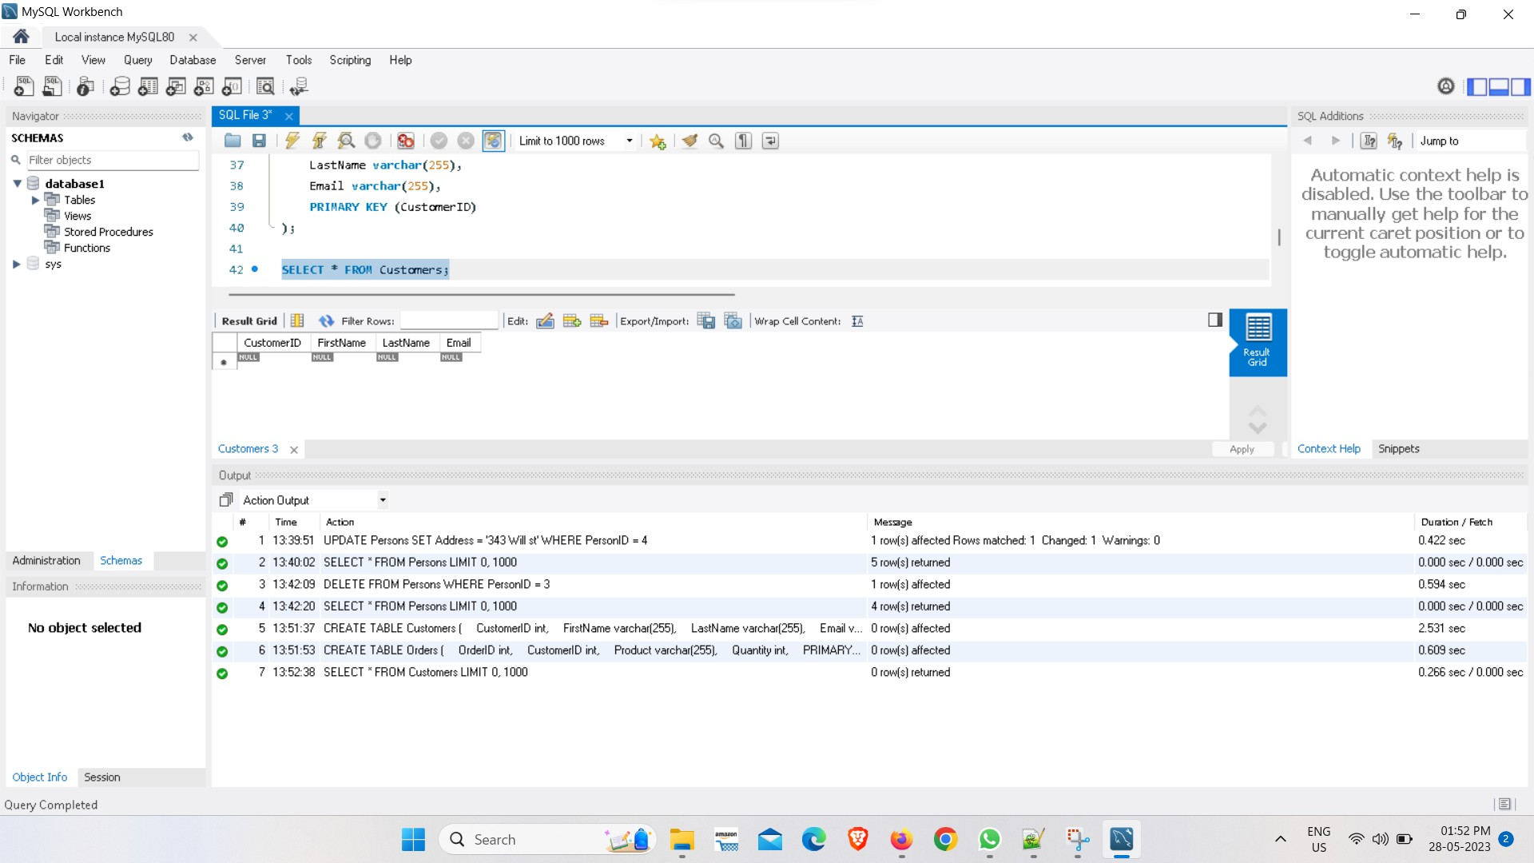

CREATE TABLE Orders (

OrderID int, CustomerID int, Product varchar(255), Quantity int,

PRIMARY KEY (OrderID),

FOREIGN KEY (CustomerID) REFERENCES

Customers(CustomerID)

);

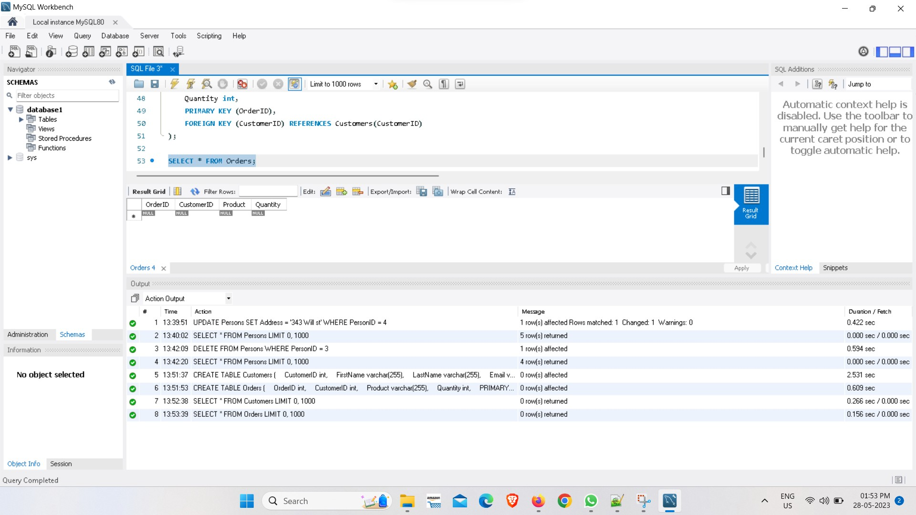

# JOIN:

SELECT Customers.FirstName, Customers.LastName, Orders.OrderID, Orders.Product, Orders.Quantity

FROM Customers

JOIN Orders ON Customers.CustomerID = Orders.CustomerID;

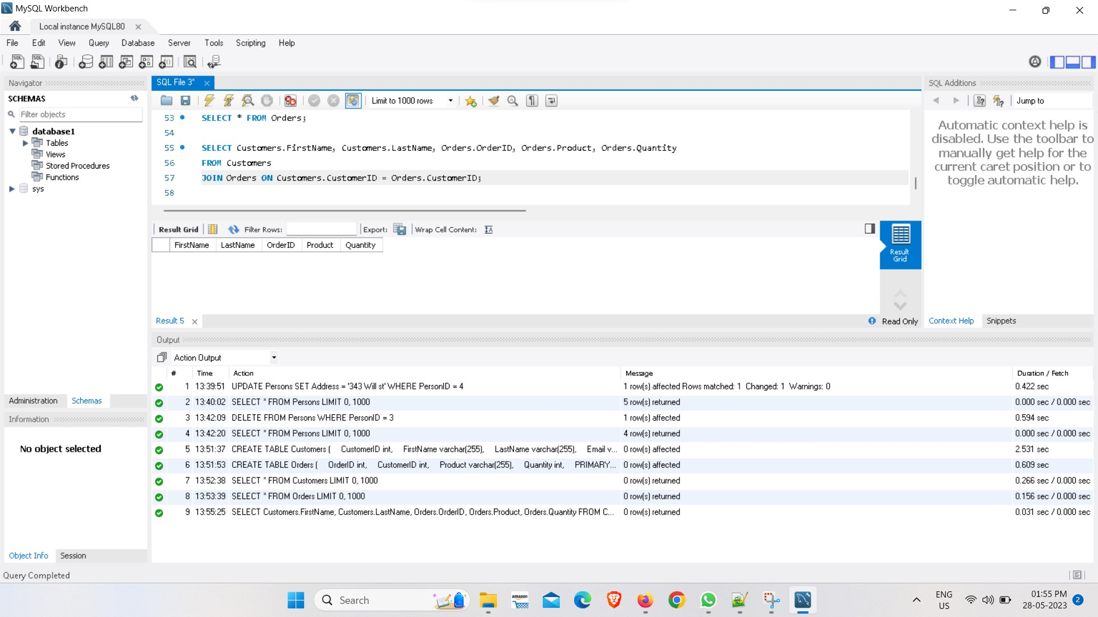

# INNER JOIN:

SELECT Customers.FirstName, Customers.LastName, Orders.OrderID, Orders.Product, Orders.Quantity

FROM Customers

INNER JOIN Orders ON Customers.CustomerID = Orders.CustomerID;

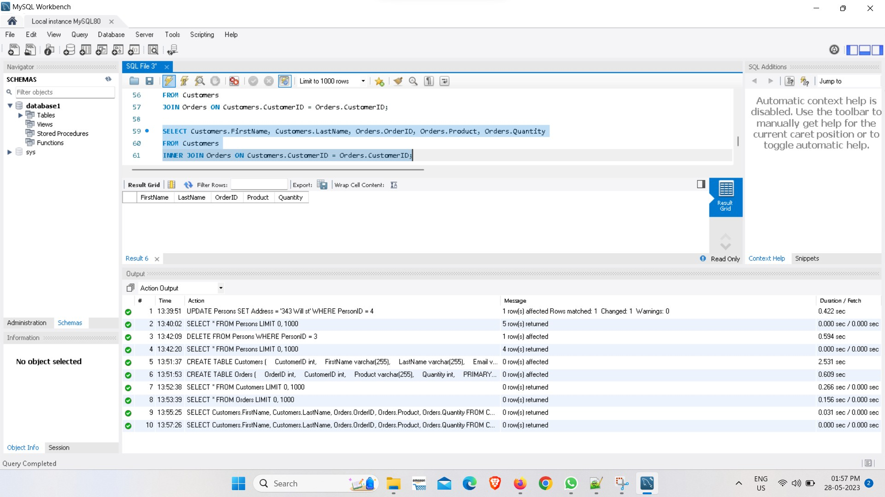

# RIGHT JOIN:

SELECT Customers.FirstName, Customers.LastName, Orders.OrderID, Orders.Product, Orders.Quantity

FROM Customers

RIGHT JOIN Orders ON Customers.CustomerID = Orders.CustomerID;

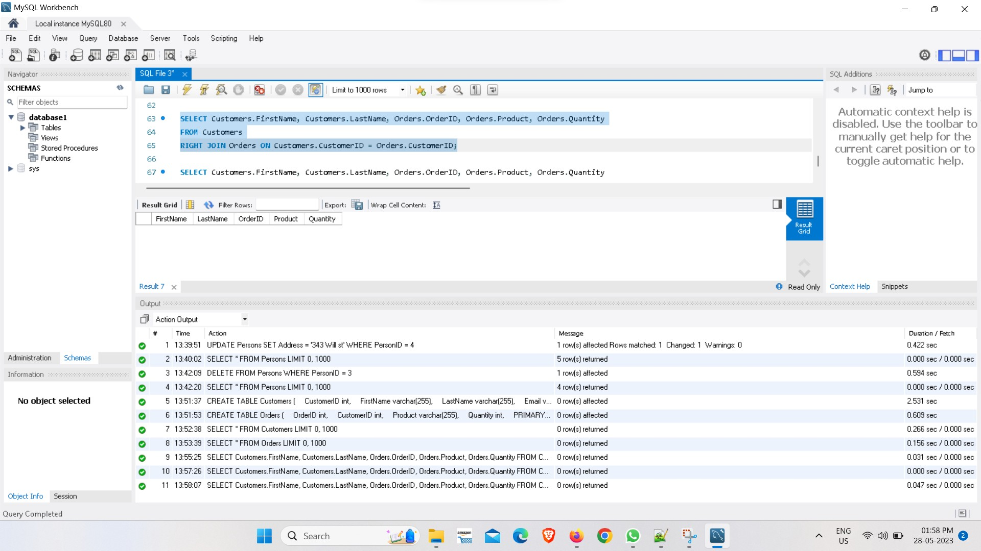

# LEFT JOIN:

SELECT Customers.FirstName, Customers.LastName, Orders.OrderID, Orders.Product, Orders.Quantity

FROM Customers

LEFT JOIN Orders ON Customers.CustomerID = Orders.CustomerID;

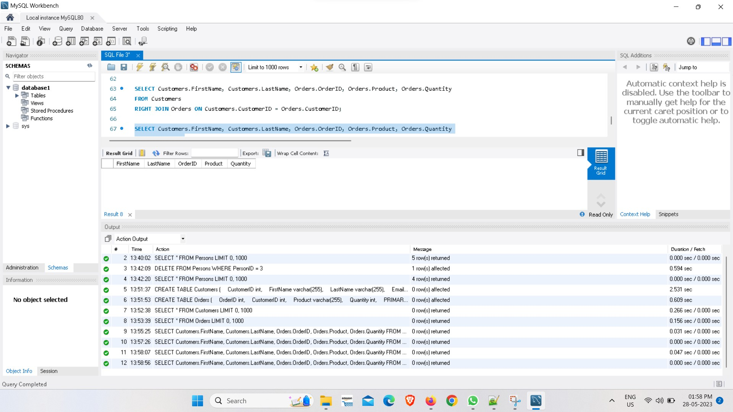

# Create , update, delete commands in mongo Create:

db.Persons.insertOne({personid:"1",name:"williams",age:"20",Adress:"852 pine st"}) db.Persons.insertOne({personid:"3",name:"john",age:"21",Adress:"564 main st"}) db.Persons.insertOne({personid:"2",name:"smith",age:"19",Adress:"123 will st"}) db.Persons.insertOne({personid:"4",name:"jane",age:"23",Adress:"496 elm st"}) db.Persons.insertOne({personid:"5",name:"johnson",age:"22",Adress:"480 main st"})

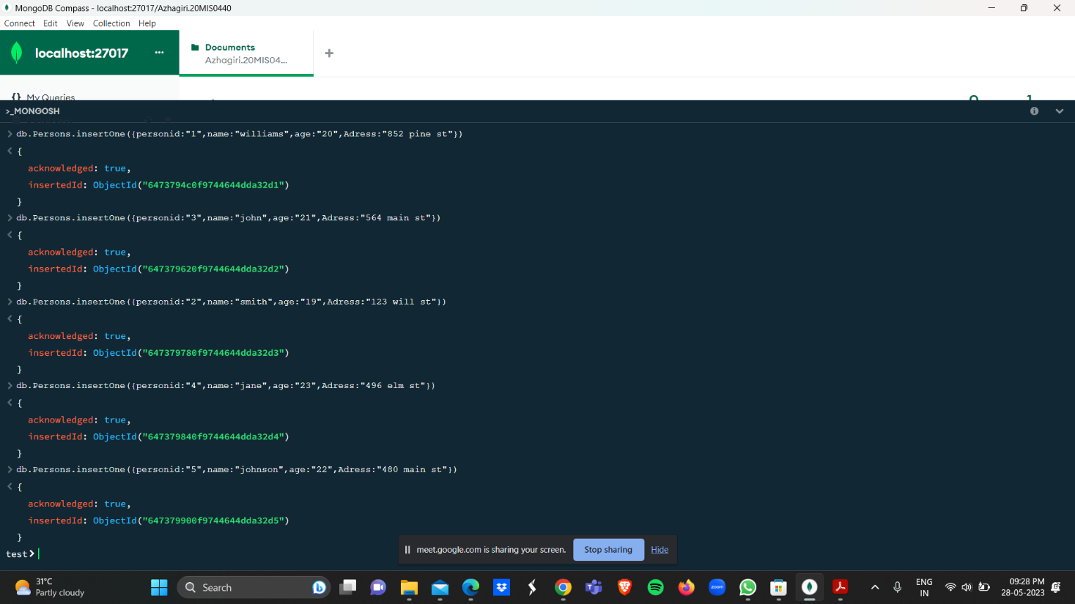

# Update:

db.Persons.updateOne({_id:ObjectId('64732a2f1ad1dfd43f46f571')}, {$set:{age:"24"}})

db.Persons.findOne({age:"24"})

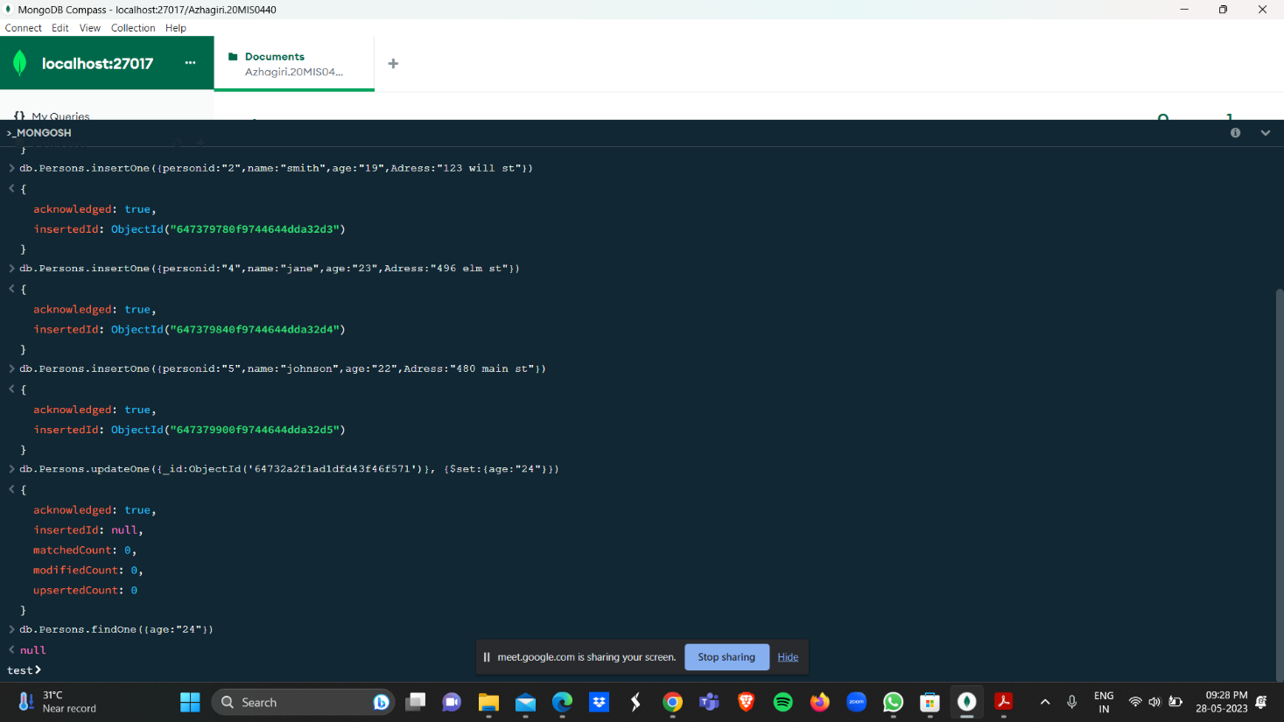

**Delete:** db.Persons.deleteOne({name:"smith"}) db.Persons.find()

